**Exercise on GitHub and Git**

**PART 1:**

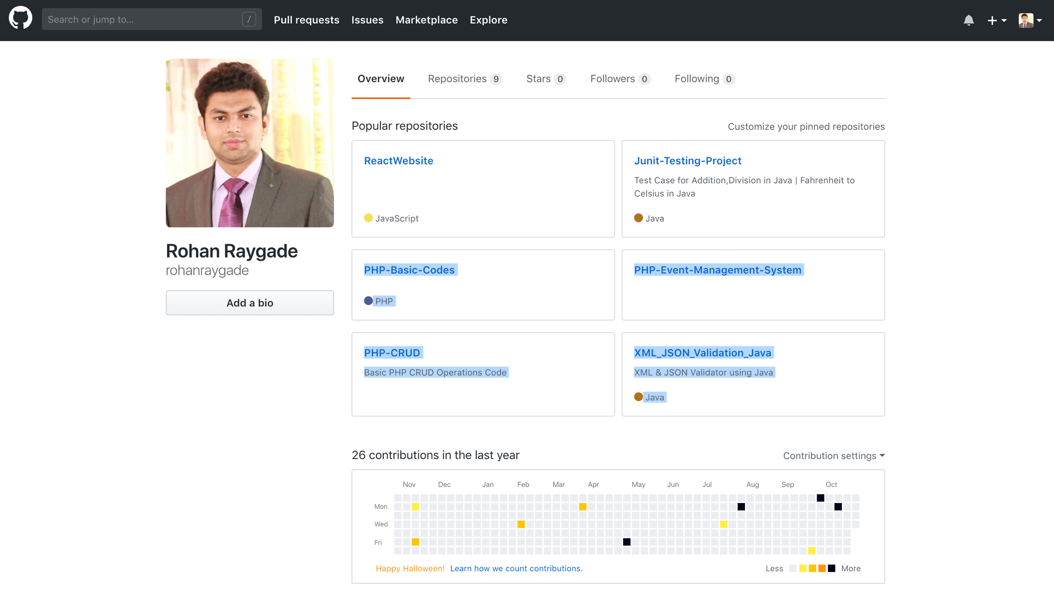

**PART 2:**

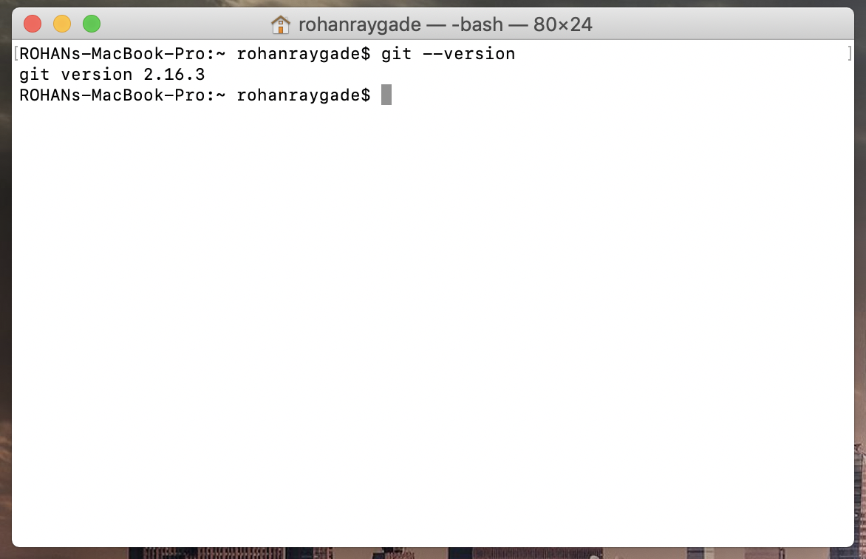

**PART 3:**

**What is GitHub? When was it created? Why? By who? What similar platforms exist? Why would you use such a platform?**

Ans. Github is a web based hosting controlled by Git with a simplified UI. Git can be controlled through GitHub for desktop /Gitbash.

It was created by Chris Wanstrath, PJ Hyett, Tom Preston-Werner and Scott Chacon

in Feb 2008. It was created to host open source projects and private too with a access to a Github UI which also supports version control system.

Similar platforms like github are GitLab, BitBucket, Launchpad, Sourceforge etc.

These are open source repository hosting site where your code is hosted on cloud. While, it is easy to keep a track of your code changes using version control system. It is one of the safe place to keep your project/code hosted.

**PART 4: Screenshot for Git Tutorial Trail**

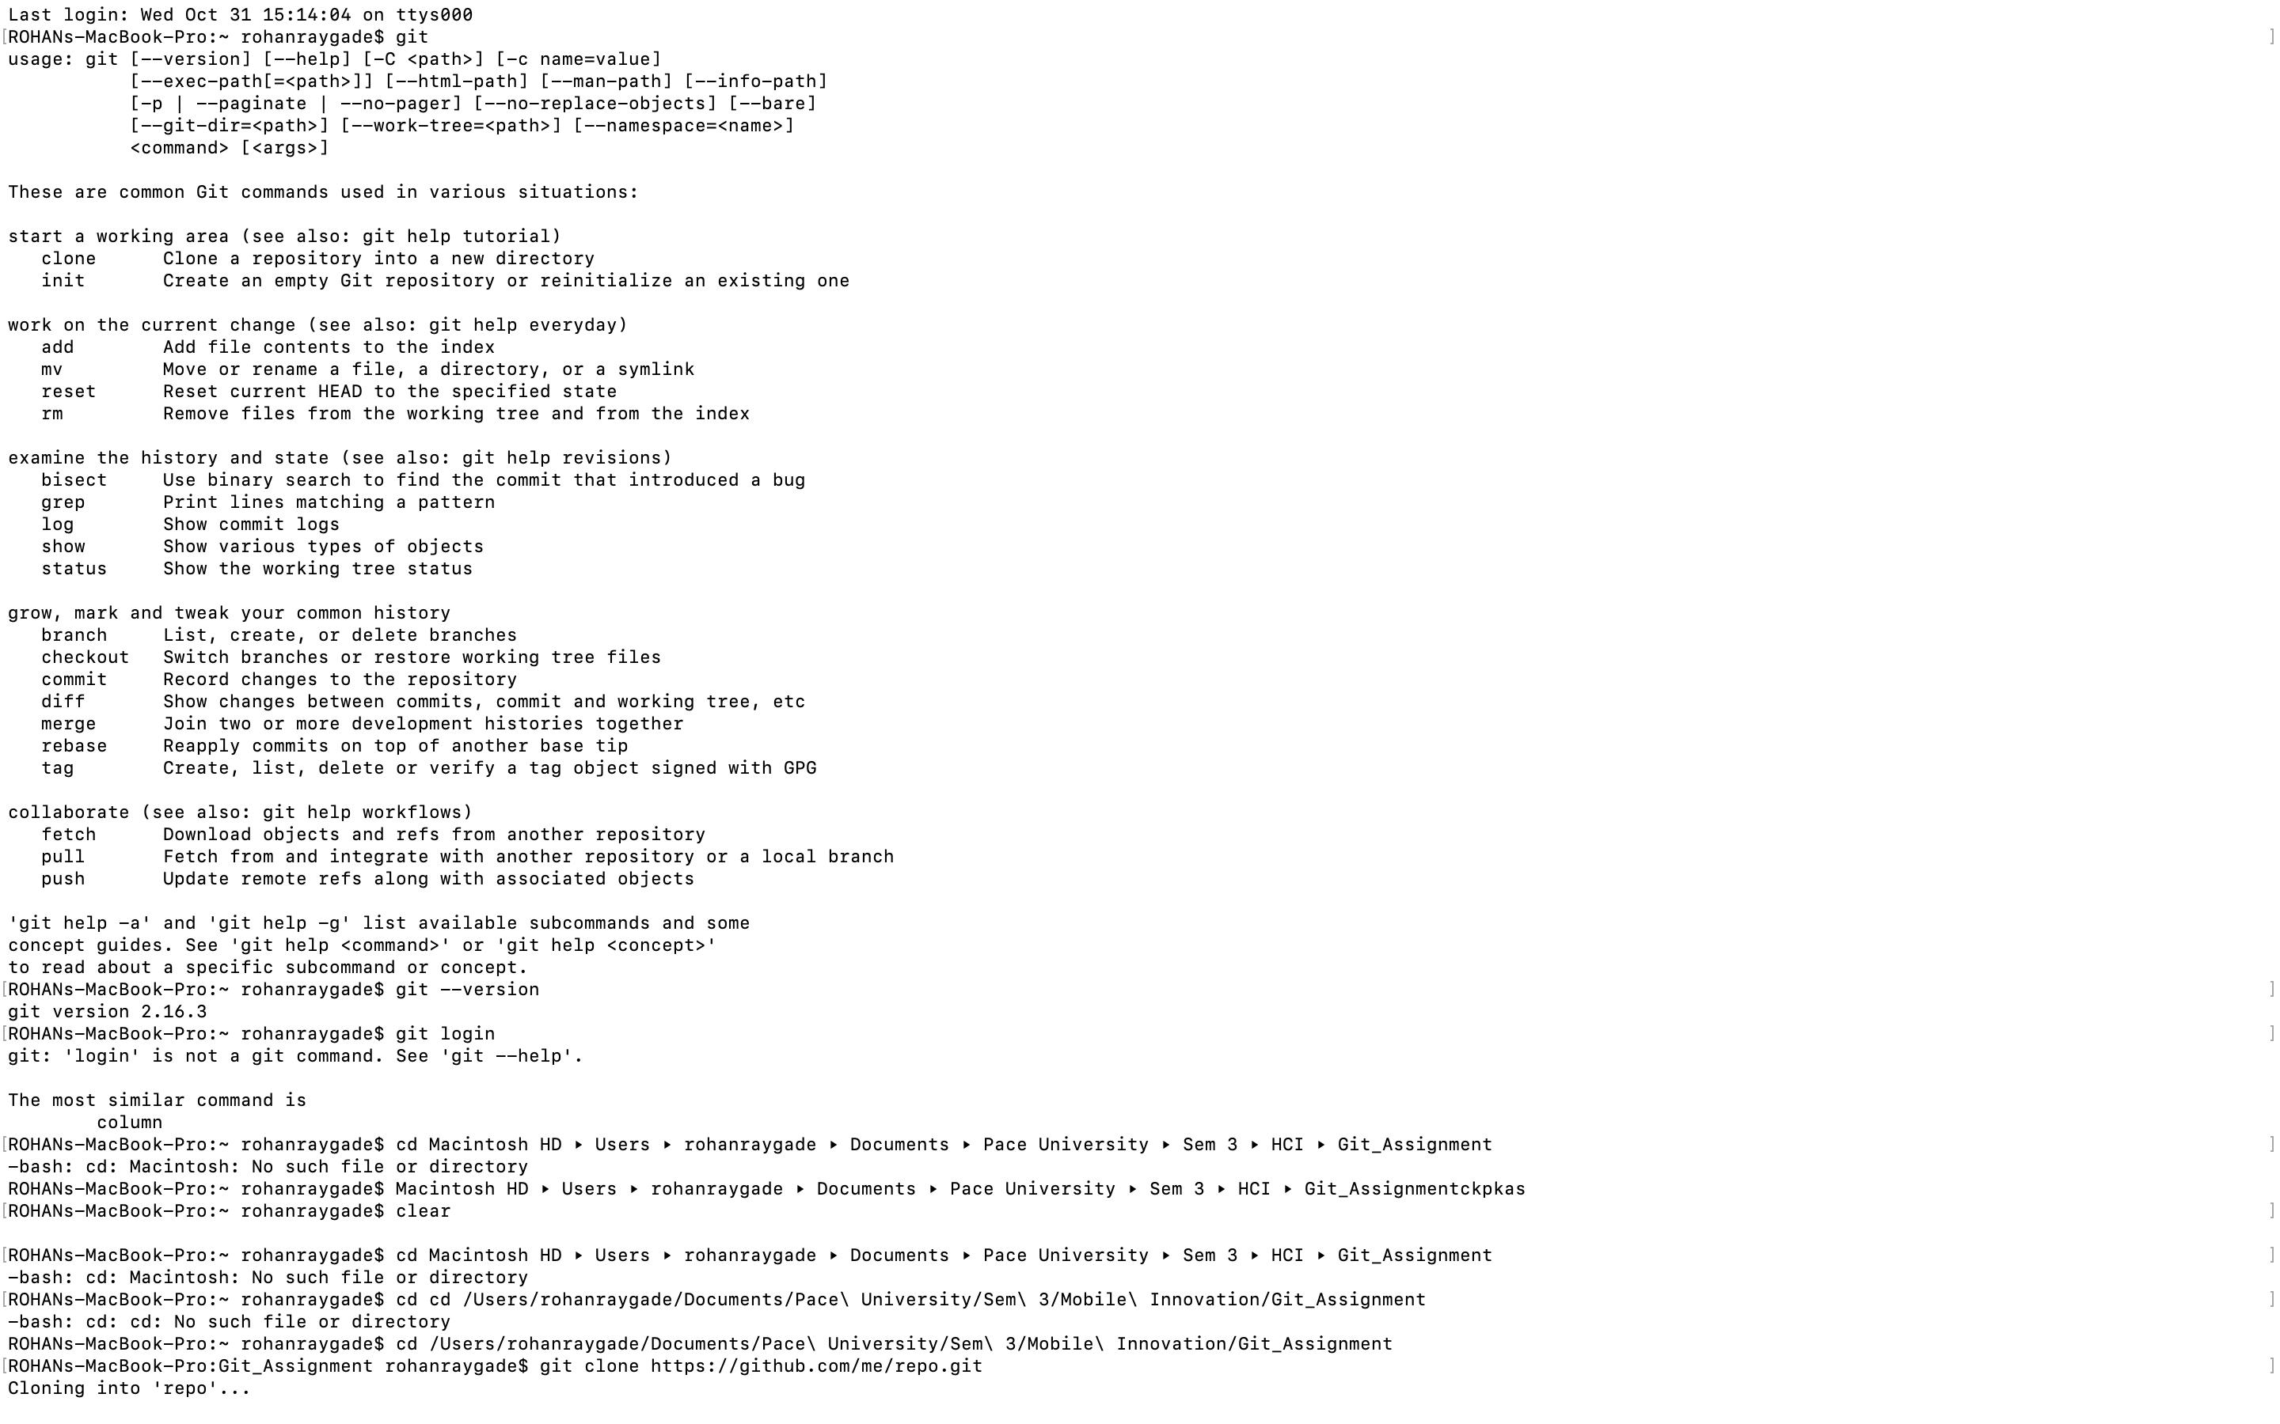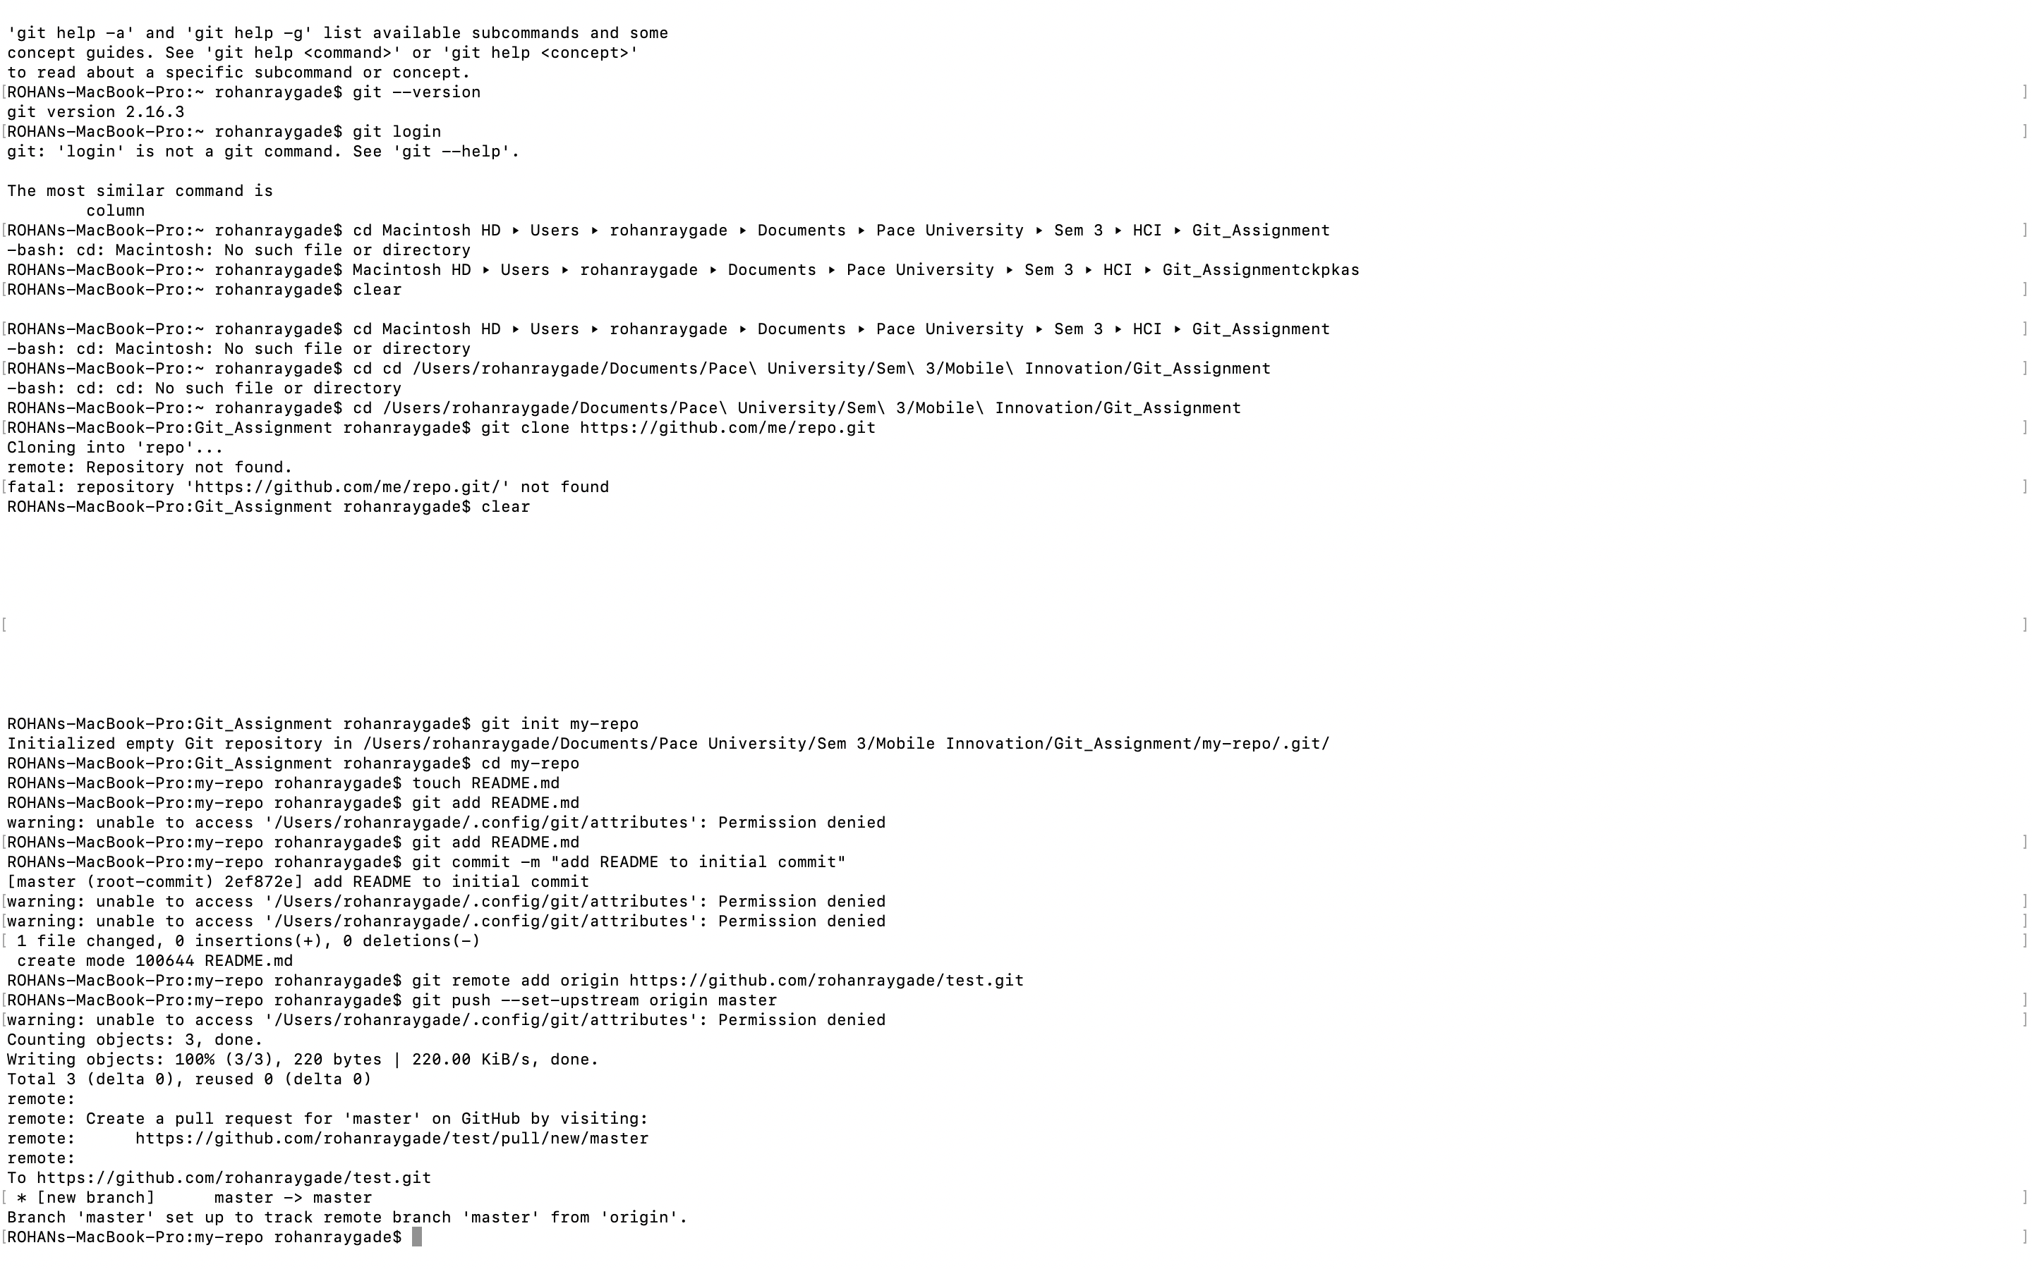

**PART 5:**

* **Repository:** It acts as a folder where you store your project all it’s file. While you can keep updated files and older files too using version control. It can be a public or private repository too.
* **Commit**: Changes to the files made is called commit. Commit can be refered to as revision to the file. It keeps track of your file where you can comment to every file commited on the repository
* **Push:** After committing a file it is pushed to a repository. So that it can be accessed later on.
* **Branch:** Branch is just like a duplicate branch to master branch where changes made to your branch won’t affect your master branch. This is used to keep track of your changes to the file/project.
* **Fork:** Fork is used to make your local copy to another user’s repository which is interegrated into your account repositories. Here you cannot make changes to user master branch and have access to local version copy only.
* **Merge:** Merge takes places when you want to merge to files as a part of pull request. So, that you can update your repositiory files. Command line is generally used to perform merge
* **Clone:** Clone gives you the duplicate copy of your repository Where changes made to your local copy can be pushed to master copy. Generally, version controlled is used here to push changes to the file before pushing it to master file.
* **Pull:** Pull is when you want to get the lastest updated files from the repository as a part of merging
* **Pull request:** pull request happens when you want to pull latest files from the repository.

**PART 6: Pushing word file into repository CS6432018**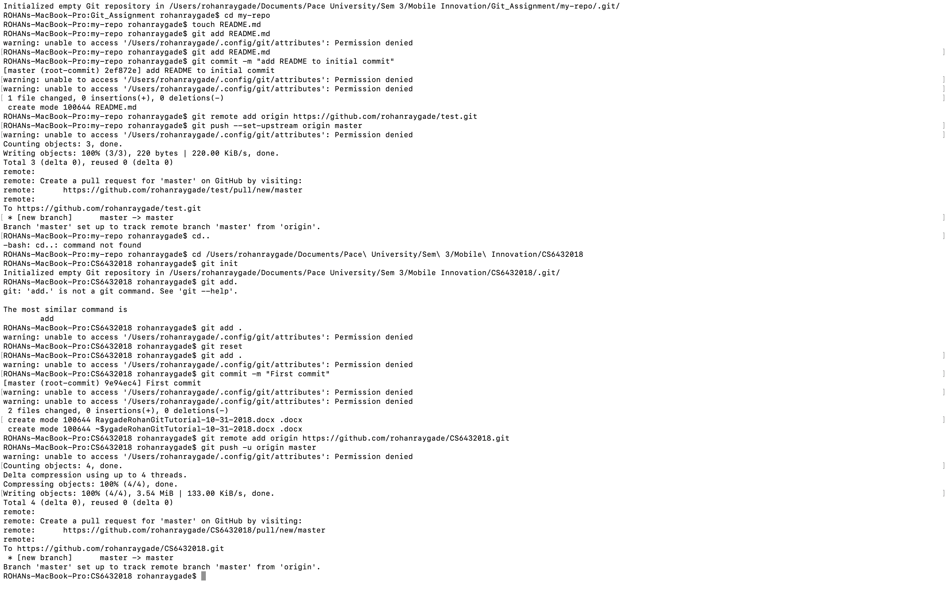

**PART 7: Name Added**

